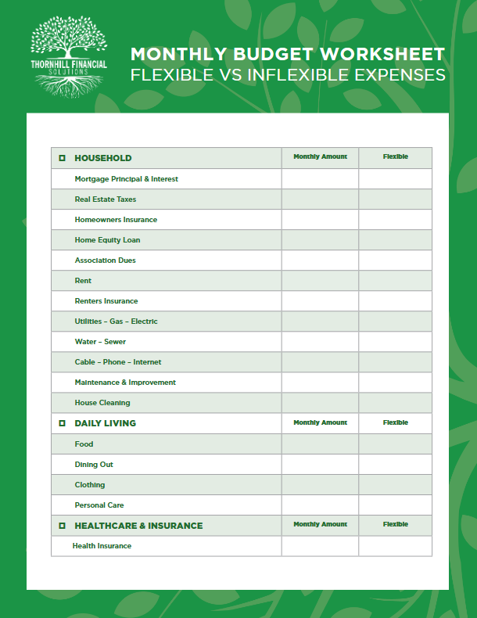
JWH Financial Service Group LLC.
John Hugee
+1 (714) 854 2769
JWH.financialgroup@outlook.com

